

**FULL PAPER**

|  |  |
| --- | --- |
| **Thin Films** | **www.advmatinterfaces.de** |

**Atomic Structure of Domain and Interphase Boundaries in Ferroelectric HfO2**

*Everett D. Grimley,* Tony Schenk, Thomas Mikolajick, Uwe Schroeder, and James M. LeBeau\**

|  |
| --- |
| **Though ferroelectric HfO2 thin films are now well characterized, little is cur-** |

**rently known about their grain substructure. In particular, the formation of domain and phase boundaries requires investigation to better understand phase stabilization, switching, and phase interconversion. Here, scan-**  
**ning transmission electron microscopy is applied to investigate the atomic structure of boundaries in these materials. It is found that orthorhombic/ orthorhombic domain walls and coherent orthorhombic/monoclinic inter-phase boundaries form throughout individual grains. The results inform how interphase boundaries can impose strain conditions that may be key to phase stabilization. Moreover, the atomic structure near interphase boundary walls suggests potential for their mobility under bias, which has been speculated to occur in perovskite morphotropic phase boundary systems by mechanisms**

|  |
| --- |
| **similar to domain boundary motion.** |

|  |
| --- |
| phase *Pca*2*1* that lacks an inversion center is thought to be responsible for the ferro- |

electric behavior of these thin films, and has been observed with scanning trans-mission electron microscopy (STEM).[11,14]

|  |  |  |  |
| --- | --- | --- | --- |
| Electron microscopy has also revealed | | | |
| |  | | --- | | interfacial | | |  | | --- | | HfO2 | | |  | | --- | | regions | | |  | | --- | | exhibiting | |
| tetragonal-like symmetry at electrode/ | | | |

|  |
| --- |
| bulk grain interfaces in moderately doped |

films,[12,15,16] and its presence dominates at high dopant concentrations.[12,13] Critically, the net electrical behavior is strongly gov-erned by the fractions of each phase in a given device.[12,13,17]

|  |  |  |
| --- | --- | --- |
| First-principles | calculations | suggest |

that various forces contribute to stabilizing the different distorted fluorite phases of

|  |  |
| --- | --- |
| **1. Introduction** | HfO2, enabling ferroelectric switching, and/or possibly allowing phase transformation. These include electric fields,[18,19] surface energies,[18,20] strain from dif- |

Following the first report of ferroelectricity in HfO2,[1] signifi-cant interest and research have been spurred on by its robust ferroelectric properties that are maintained even in films thinner than 10 nm. Because of its silicon compatibility and wide processing space, the material shows promise for use in future memories,[2,3] energy efficient logic transistors,[4,5] and devices that exploit a tunable dielectric[6] or pyroelectric.[7–9] As understanding of ferroelectricity in HfO2 develops, grain substructure is proving increasingly important for controlling film properties. While bulk HfO2 is known to adopt the *P*2*1/c* monoclinic phase (M) at room temperature and pressure,[10]“metastable” high symmetry fluorite-like phases including *P*4*2/nmc* tetragonal (T) and orthorhombic (O) phases can coexist in the ferroelectric thin films.[1,2,9,11–13] An orthorhombic

E. D. Grimley, Prof. J. M. LeBeau   
Department of Materials Science and Engineering North Carolina State University   
Raleigh, NC 27695-7907, USA   
E-mail: edgrimle@ncsu.edu; jmlebeau@ncsu.edu

Dr. T. Schenk, Prof. T. Mikolajick, Dr. U. Schroeder NaMLab gGmbH   
Noethnitzer Str. 64, 01187 Dresden, Germany

Prof. T. Mikolajick   
Institute of Semiconductors and Microsystems TU Dresden, 01062 Dresden, Germany

The ORCID identification number(s) for the author(s) of this article can be found under https://doi.org/10.1002/admi.201701258.

**DOI: 10.1002/admi.201701258**

ferent origins,[18,19,21,22] and alloying.[18] Experiment and theory point to an orthorhombic switching pathway through the tetragonal phase,[2,21–23] and in certain instances the tetrag-onal-to-orthorhombic transition might be transient during the application of an electric field.[3]   
 Recently, studies have also highlighted the structural simi-larities between the orthorhombic and monoclinic phases.[22,24] Barabash et al. report that differences in oxygen ordering in a “parent” orthorhombic phase (centrosymmetric *Pbcm*) can lead to stabilization of either the monoclinic or the polar orthorhombic phase. Furthermore, they speculate that a region of coherently strained HfO2 lacking the monoclinic distortion might readily convert between the monoclinic and polar orthorhombic phase via a low transformation barrier.[22] Experimental evidence also suggests that some amount of phase transformation may occur during the “wake-up” effect.[15,16,25–27] The complexities of characterizing polycrystalline and poly-phasic HfO2 thin films have, however, limited current informa-tion of phase distribution, coexistence, and domain structuring in this new ferroelectric system. Domains of the orthorhombic

|  |
| --- |
| ferroelectric phase are expected to exist based on the polariza- |

|  |
| --- |
| tion versus electric field response and on electrical measure- |

ments where single domain switching is observed.[28] Direct evidence of such domains, however, remains limited.[25,28,29] Beyond ferroelectric domains, other internal boundaries are also crucial to consider as they can impact a ferroelectric material’s mechanical and electrical response. This has been seen, for example, near morphotropic phase boundaries in the phase diagrams of certain materials. Pb(Zr,Ti)O3 exhibits

|  |  |  |
| --- | --- | --- |
| *Adv. Mater. Interfaces* **2018**, 1701258 | **1701258 (1 of 9)** | © 2018 WILEY-VCH Verlag GmbH & Co. KGaA, Weinheim |

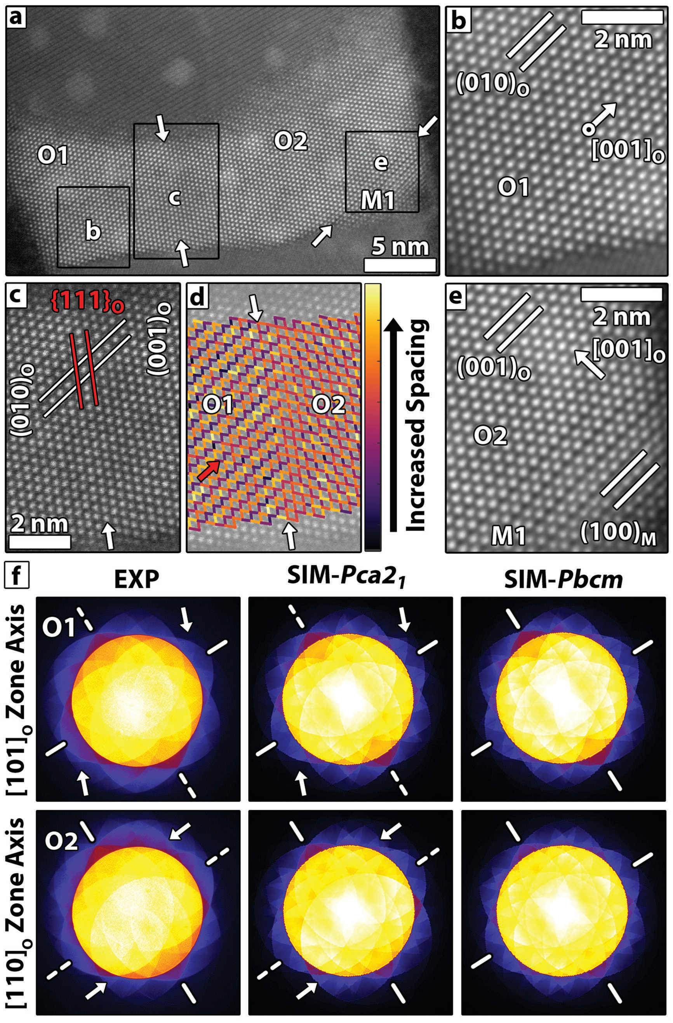

**www.advancedsciencenews.com**   
 **www.advmatinterfaces.de**

coexistence of polar rhombohedral and polar   
tetragonal phases, which exist in fractions   
and over length scales that depend largely   
on the composition.[30] Domain wall energy   
is an important parameter for determining   
the length scale of ordering and the domain   
sizes, and thus has important implications   
for mechanical and electrical behavior.[31]   
Because these systems contain multiple   
phases, “interphase boundaries” can form as   
walls between different phases. Furthermore,   
mobile interphase boundaries are speculated   
to move during cycling in both reversible and   
irreversible jumps, similar to domain walls,   
thereby converting between phases as the   
boundary wall moves.[32–34]

|  |
| --- |
| Despite indications that phase transforma- |

|  |
| --- |
| tions and other defect related phenomena |

|  |
| --- |
| take place during progressive switching of |

ferroelectric HfO2,[15,16,25–27] the underlying   
mechanisms remain unclear. The presence of   
interphase boundaries, for example, would be   
expected to influence phase stability by intro-  
ducing internal strains,[18,19,22] and electrical   
properties if the boundaries move during the   
application of an electric field.[32,34] Identifi-  
cation of the phase and ferroelectric domain   
structures would thus lead to approaches to   
further improve this lead-free ferroelectric.

In this article, interphase boundaries and   
single phase domains in Gd doped HfO2   
metal-ferroelectric-metal capacitors are   
studied using aberration corrected STEM.   
Monoclinic, orthorhombic, and tetragonal   
regions are found to coexist within single   
grains. Within orthorhombic domains, 90°  
domain walls are found only in the pris-  
tine samples, suggesting that their presence   
is altered by field-cycling. Monoclinic/   
orthorhombic interphase boundaries are also   
revealed and analyzed in the context of the   
structural parameters that govern their for-  
mation. Moreover, our results highlight the

similarities between the orthorhombic and monoclinic phases. These similarities lead to challenges in distinguishing a “defect” in one phase from the “normal” structure of the other phase. These combined results sug-gest that the environments near interphase boundaries lead to the formation of new orthorhombic regions. Contingent on the

**Figure 1.** a) HAADF STEM of a pristine Gd doped HfO2 grain with O and M regions separated by boundaries indicated by white arrows. c) Magnified view of the O1/O2 boundary from (a), with d) displaying distances between atom columns as colored lines to emphasize changes in projected symmetry (red arrow provides a visual guide). b,e) magnified regions from (a) where planes are indicated with lines and the polar direction by arrows. f) Experiment and simulated PACBED patterns corresponding to O1 and O2 regions. The presence and lack of a mirror plane are solid and dashed lines, respectively. Arrows highlight symmetry breaking in the pattern. Brightness and contrast are adjusted to emphasize PACBED pattern asymmetry.

stability/mobility of these boundaries, such boundaries are pro- distance between the two dark electrodes in **Figure1**a. To sim-

posed to play a role in phase conversion under an electrical bias.

**2. Results and Discussion**

HfO2 grains typically span the thickness of the film between

the TiN electrodes, as shown by the bright grain spanning the

plify the referencing of regions within the various images, we sequentially number the monoclinic (M) or orthorhombic (O) regions. Using high-angle annular dark-field (HAADF) STEM, the identity and orientation of phases in HfO2 films are readily determined using the atomically resolved positions of the pro-jected Hf atom sublattice.[11,16] This analysis reveals that certain grains exhibit a complex domain structure. For example, a

|  |  |  |
| --- | --- | --- |
| *Adv. Mater. Interfaces* **2018**, 1701258 | **1701258 (2 of 9)** | © 2018 WILEY-VCH Verlag GmbH & Co. KGaA, Weinheim |

**www.advancedsciencenews.com**

**www.advmatinterfaces.de**

single grain is divided into two orthorhombic (O1, O2) and one monoclinic (M1) region in Figure 1a. At the O1/O2 boundary in Figure 1c, (010)o in O1 is parallel to (001)o in O2, where {111}o is continuous across the domain wall. The boundary between the two regions is sharp and possesses an abrupt change in projected symmetry at the domain wall. This symmetry change is made more visible by inspection of the atom column near neighbor distances, which are mapped in Figure 1d. An inter-phase boundary is also observed within the same grain (see Figure 1e), where the crystal structure abruptly transitions from O2 to M1 with (001)o‖(100)m.

Connecting structure to polarization is essential for under-standing the ferroelectric behavior of HfO2 thin films. Polarization across the O1/O2 domain wall can be assessed by position-averaged convergent beam electron diffraction (PACBED), where missing mirror symmetry in the pattern cor-responds to a lack of inversion symmetry in the material.[11,35] This occurs for the *Pca*2*1* orthorhombic phase along the [001]o, and is indicated by arrows in Figure 1b,e (note that the [001]o in Figure 1b is inclined with respect to the image plane, pos-sessing a partial out-of-plane component). Figure 1f shows PACBED patterns acquired from regions O1 and O2. Each pat-tern lacks a mirror plane across the dashed axis bisecting the pattern, which is consistent with the *Pca*2*1* polar phase simula-tions. In contrast, simulated patterns from the centrosymmetric

*Pbcm* phase retain mirror symmetry along both axes. These results show that the polar direction is rotated by ≈90°, hence forming a 90° domain wall.

More broadly, a wide range of interphase and domain boundaries are observed throughout the samples as highlighted by **Figure2**a–d. The images reveal several O/O domains and O/M interphase boundary structures in a variety of shapes and sizes. Changes in atom column spacing and symmetry across the boundaries are highlighted by near neighbor distance maps in the bottom panels of Figure 2a-d. While some boundaries are angular and difficult to precisely locate, others are flat with fractional unit-cell steps. Figure 2a shows a typical 90° domain between orthorhombic regions O3 and O4. As in the case of the O1/O2 boundary in Figure 1c, (010)o becomes (001)o across the O3/O4 domain wall. The transition in crystal symmetry is abrupt, and like the O1/O2 boundary, occurs over a higher order crystal plane. Not all boundary transitions are sharp in the vicinity of 90° domain walls. For example, Figure 2b shows a 90° domain wall formed at the interface between regions O5 and O6. Unlike the O/O domains in Figures 1c and 2a, (001)o of this domain remain parallel across the boundary and instead rotate 90° in-plane.

Based on the domain walls presented in Figures 2a,b, which are viewed down low order zone axes, some aspects of the structure of orthorhombic domain boundaries can be linked

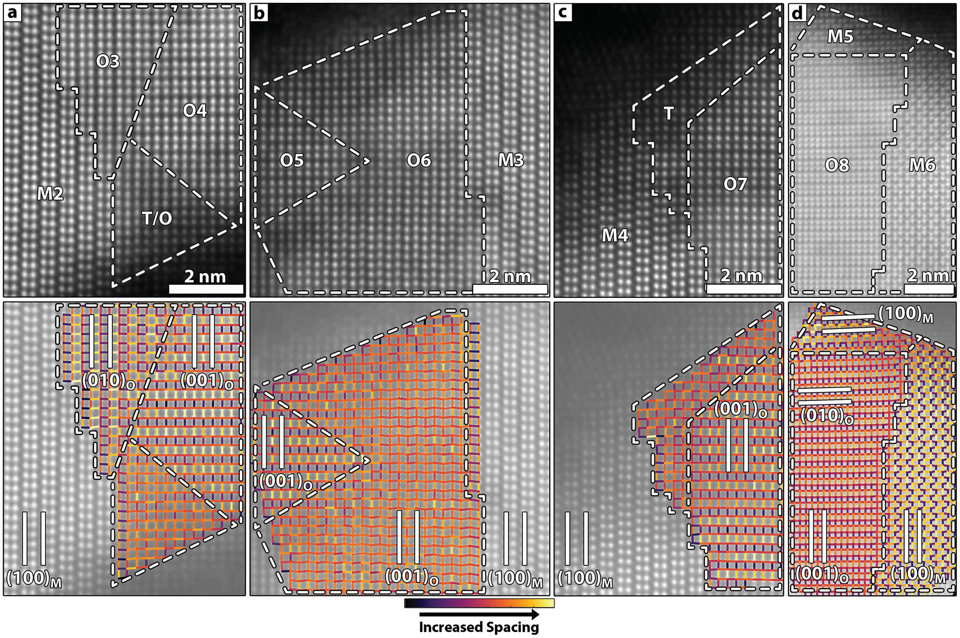

**Figure 2.** a–d) HAADF STEM images of various regions containing O/O domains and/or O/M interphase boundaries. Dashed lines indicate domain/ interphase boundaries. White lines denote indicated Hf planes. Short, colored lines map distances between neighboring Hf sublattice atom columns to help guide the eye. Figure 2 can be found without overlays in Figure S2 (Supporting Information). Regions (a)–(c) are from a pristine sample while (d) is fatigued.

|  |  |  |
| --- | --- | --- |
| *Adv. Mater. Interfaces* **2018**, 1701258 | **1701258 (3 of 9)** | © 2018 WILEY-VCH Verlag GmbH & Co. KGaA, Weinheim |

**www.advancedsciencenews.com**

to misfit. As reported in ref. [11], the lattice parameters of the orthorhombic structure are *a*o, *b*o, *c*o= 5.24, 5.06, 5.07 Å, which results in a ≈0.2% misfit across the O3/O4 domain wall and a rather abrupt change in rotation across the boundary. In con-trast, the O5/O6 boundary exhibits high misfit of ≈3.5%, and possesses a much more diffuse transition in structure across the boundary. This likely arises due to the larger misfit and/ or grain overlap. The three examples of orthorhombic domains in Figures 1c and 2a,b exemplify how local environments allow domains to form in a variety of orientations, sizes/shapes, and domain wall configurations.

The monoclinic phase is found to form twin boundaries in some grains. For example, a (110)m twin in Figure 2d is identi-fied between the monoclinic regions M5 and M6. Twining also occurs on (001)m (Figure S1a, Supporting Information) and (100)m (Figure S1b, Supporting Information). These twin planes are in good agreement with various reports of twinning con-figurations identified in toughened zirconia ceramics,[36] HfO2 thin films grown directly on Si,[37] and in Hf-rich Hf*x*Zr1 −*x*O2 nanocrystals.[38] Twinning is associated with the tetragonal to monoclinic martensitic phase transformation.[36–39] Such a phase transformation requires a shape change to the distorted monoclinic cell, and twinning is a mechanism whereby shape change/shear strain can be minimized for the transformation of a confined grain.[36]   
 Figure 2a-d also shows that many HfO2 regions con-tain interphase boundaries. In Figure 2a, an interphase boundary between M2/O3 regions forms with an interface with (100)m‖(010)o. The interphase boundary wall is discon-tinuous, with steps forming every few nanometers. Strain near the wall results in visible distortion of the spacing and angle between atom columns in the vicinity of the boundary, as seen in the Figure 2a distance map. Similarly, the structures become blurred adjacent to the boundary wall, which can indi-cate phase overlap or non-uniform lattice distortion near the boundary. Furthermore, the M4/O7 boundary in Figure 2c forms an interface with (100)m‖(001)o, and where lattice distor-tion visible in the vicinity of the interface. Visually, the M4/O7 interphase boundary resembles the M2/O3 boundary, but the orthorhombic region is rotated 90° such that (001)o forms the boundary rather than (010)o.

In addition to the M/O boundaries in Figure 2a,c the tetragonal phase is observed near the TiN electrodes. Interfa-cial HfO2 layers near TiN electrodes are previously reported to relax towards tetragonal symmetry in some instances which may arise from local chemical/bonding changes, changes in local oxygen vacancy concentrations, or from local orienta-tion relationships between the TiN/HfO2.[15,16] These findings

|  |
| --- |
| suggest that the environment near interphase boundaries can |

help stabilize the tetragonal phase. For instance, the T regions at the M/O boundaries in Figure 2a,c penetrates around ≈2–4 nm into the bulk grain, which is deeper than previously reported at grain/electrode boundaries.[16] Transition regions with mixed/strained symmetry like the tetragonal interface layers reported earlier can be important for phase stabiliza-tion.[40] Due to the complex nature of this polycrystalline inter-face, however, further studies are needed to form a complete picture of bonding and orientation relationships for the HfO2/ TiN interface.

The interphase boundaries in Figure 2b,d have reduced step density compared to those in Figure 2a,c. For example at the O6/M3 interface in Figure 2b, an abrupt interphase boundary is formed with (001)o‖(100)m. The transition in crystal symmetry from orthorhombic to monoclinic is sharp in this case, having less distortion. Further, the boundary between the O8/M5 regions shows no clear steps between the (010)o‖(100)m planes that form the wall in Figure 2d. A second boundary in this region also forms between O8/M6 regions with (001)o‖(100)m, with varied step density. Furthermore, the O6/M3 and O8/M6 interphase boundaries are equivalent, though they are viewed along different crystal projections.

Based on these observations, interphase boundaries are expected to traverse complicated, 3D paths through the grain. The nature of the final boundary thus depends on the size and orientation of the separate phase regions that form during annealing until they merge to form a boundary wall. Further-more, some of the distortion visible near the domain walls is likely the result of viewing a projection of the 3D domain wall structure.

The library of observed interphase boundaries gives insight into how crystal chemistry may influence their formation. The examples of interphase boundaries in Figures 1 and 2 suggest that the monoclinic and orthorhombic phases tend to form coherent boundaries across low order planes in polycrystalline HfO2 thin films. This is consistent with phase boundaries seen in strained epitaxial (Hf,Zr)O2 thin films.[29] Additionally, the boundary step structure suggests a role of misfit in determining their periodicity. The misfit here is defined as the difference in lattice parameters divided by their average. For example, the greatest possible uniaxial misfit occurs at O/M boundaries where the *c*m axis of the monoclinic phase (*c*m= 5.30 Å) aligns to either the orthorhombic *b*o axis (≈4.6% misfit) or *c*o axis (≈4.4% misfit), where *c*o= 5.07 Å and *b*o= 5.06 Å. These bound-aries with maximum misfit still form and readily step as seen in Figure 2a,c. Comparatively, when O/M boundaries form such that the *a*o and *c*m axes are parallel, misfit is significantly reduced to ≈2.0% when *b*m//*c*o and ≈2.2% when *b*m//*b*o, where *b*m= 5.17 Å. These lower misfit boundaries subsequently con-tain fewer steps as seen in Figure 2b,d.

**Figure3** shows structural schematics of an interfacial plane, focusing on the Hf positions. Only a single variant of the boundary is shown here, i.e., rotating the orthorhombic lattice in-plane by 90° will change the interface orientation, strain, and alignment of the atoms. Because the (010)m is nonorthog-onal (β= 99.18°), there is relatively poor registration to all orthorhombic planes. In contrast, the set of boundaries formed with (100)m and (001)m provide reasonable registry with the low order orthorhombic planes.

Both orthorhombic and monoclinic cells possess reduced symmetry involving lateral and out-of-plane shifts in atom posi-tions. When viewed from the side, Figure 3, the Hf sublattice remains coplanar for the (100)m, (001)o, and (010)o, while it is rumpled out-of plane for (010)m, (001)m, and (100)o. Based on these observations, interphase boundaries tend to form in orientations that maintain a co-planar Hf sub-lattice across the boundary, i.e., without out-of-plane rumpling. Additionally, the local Hf-O bonding configuration across the boundary may also play a role. Furthermore, this finding is in good qualitative

|  |  |  |
| --- | --- | --- |
| *Adv. Mater. Interfaces* **2018**, 1701258 | **1701258 (4 of 9)** | © 2018 WILEY-VCH Verlag GmbH & Co. KGaA, Weinheim |

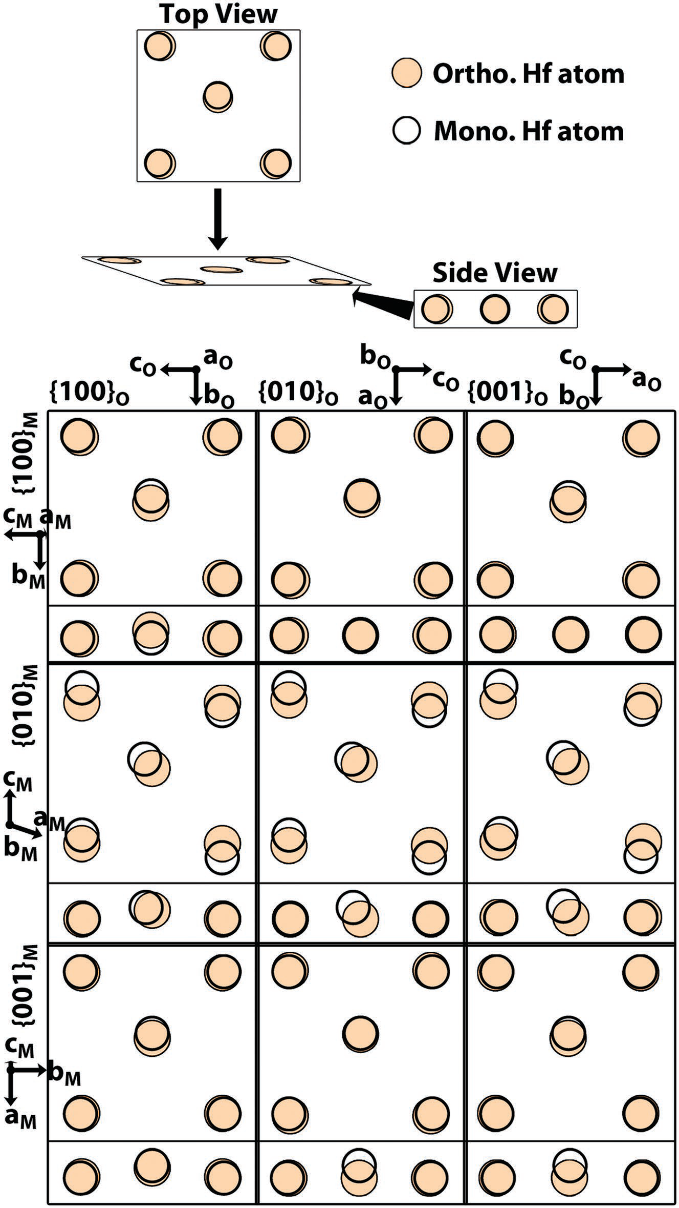



shaded terminal Hf planes at the boundaries are those of   
the orthorhombic phase. Note that both phases have three-  
coordinate and four-coordinate oxygen atom positions. Because   
the oxygen sub-lattices are not observed in the STEM images,   
the schematics are approximate and represent one of several   
possible configurations. Nonetheless, the boundaries show how   
O/M boundaries can form that reasonably satisfy the symmetry   
of both phases.

The variety of observed interphase boundaries provides   
insight into how they might influence phase stabilization   
and enable phase transformation. Immobile boundaries arti-  
ficially limit the grain size and impart a coherent strain onto   
the lattices, which is known to play an important role in phase   
stabilization.[18,19,22] Furthermore, these boundaries can influ-  
ence domain pinning. A boundary capable of moving under   
the influence of an electric field would alter the electrical   
behavior by changing the phase fractions during cycling. For   
example, monoclinic/orthorhombic phase transformations   
have been initiated during electron beam irradiation in both   
zirconia particles[43] and ceramics.[44] Similarly, monoclinic/   
tetragonal boundary propagation has been visualized during   
in situ heating/cooling of zirconia nanoparticles.[39] While the   
boundaries observed here did not move during STEM imaging,   
identical boundary orientations exhibit several different unique   
features that are not present in all instances and may suggest   
potential for mobility, as will now be discussed.

With respect to boundary mobility and unique boundary fea-  
tures, **Figure5**b is instructive. This (010)o‖(100)m boundary is   
oriented equivalently to ones previously shown to be mobile   
in particles of the related zirconia crystal structure.[43] This   
boundary also displays many unique features that set it apart   
from the similar boundary presented earlier in Figure 2a.   
Distinct orthorhombic O9 and monoclinic M7 regions are   
separated by a complicated interphase boundary, which is seg-  
mented into regions R1 and R2 by the dotted lines within the   
boundary region in Figure 5b. The qualitative symmetry of the   
Hf sublattice is indicated by colored overlays with black indi-  
cating pure orthorhombic symmetry, red representing pure   
monoclinic symmetry, and white labeling regions where the Hf

**Figure 3.** Schematic of a single Hf plane in monoclinic (open circles) and orthorhombic (filled circles) cells viewed from the top and side. The O sublattice is omitted because it is not observed in the HAADF STEM images. The structures are derived from unit-cell parameters from ref. [10] for the monoclinic cell and refs. [11,41] for the orthorhombic cell.

agreement with studies that show the (100)m habit is the more favorable habit planes for related zirconia phase transforma-tions.[42] Strain and displacements of the Hf sublattice needed to form certain rumpled boundaries (i.e., any boundaries with the (001)m plane) do not appear dramatically different than that of the observed boundaries. While the results suggest prefer-ence for nonrumpled boundaries involving the (100)m, the existence of rumpled boundaries from this system cannot be ruled out due to the inherently limited sampling statistics of atomic resolution electron microscopy. Further investigations combined with theory are needed to provide further insight into boundary stability and preference.

Approximate configurations of the structures observed at interphase boundaries are provided in **Figure4**. The

sublattice seemingly cosatisfies the symmetry of each phase.

The monoclinic and orthorhombic unit cells can be thought of as distorted tetragonal unit cells.[45] Half the structure resem-bles, with minor distortion, the parent tetragonal phase, while the other half deviates significantly for both monoclinic and orthorhombic cells, see Figure 5a. The layers with minor distor-tions are structurally very similar between the monoclinic and orthorhombic phases. By contrast, the majority of the differ-ences between the monoclinic and orthorhombic phase occur within the major distortion layers.

The nominal structures of the major distortion layers are labeled in Figure 5b. Several interesting structural features occur in this boundary. First, the bottom red arrow in R2 indi-cates a monoclinic-like major distortion layer that becomes an orthorhombic-like major distortion layer across the R2/R1 boundary. Next, the monoclinic major distortion layer at the same red arrow appears “twinned” with respect to the monoclinic major distortion layer indicated by the top red arrow. This twin-like feature occurs across a major distor-tion layer resembling the orthorhombic phase (black arrow).

|  |  |  |
| --- | --- | --- |
| *Adv. Mater. Interfaces* **2018**, 1701258 | **1701258 (5 of 9)** | © 2018 WILEY-VCH Verlag GmbH & Co. KGaA, Weinheim |

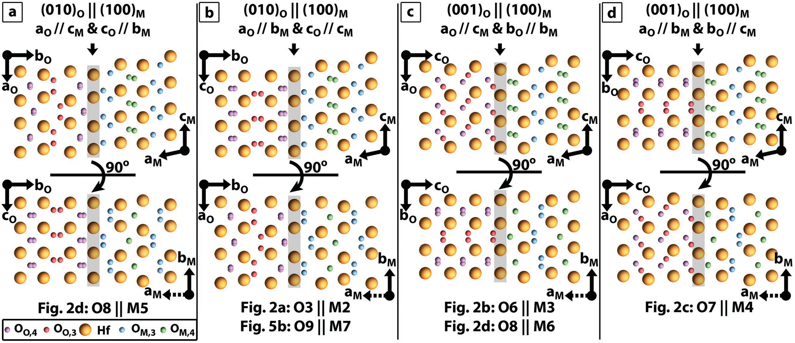



**Figure 4.** Schematics of the observed O/M (left/right) interphase boundaries. Top labels indicate the boundary orientations. Bottom schematics are

rotated 90° relative to the top view. The image/phase pairs where these boundaries are found in the HAADF STEM images are listed beneath each

schematic. The oxygen phase and coordination are also provided.

The monoclinic-like major distortion layer indicated by the top red arrow occurs between two major distortion units with orthorhombic-like structures. From this analysis, it becomes apparent that substitution of a monoclinic-like major distorted layer into an orthorhombic lattice results in an anti-phase-like boundary in the orthorhombic phase (see top red arrow in Figure 5b and red arrow in Figure 5c). Similarly, insertion of an orthorhombic-like major distortion layer into the mono-clinic lattice results in a “twin-like” defect (see black arrow in

an internal force. Domain boundaries have been suggested as stabilizing higher symmetry phases in zirconia nanoparti-cles,[46] and interphase boundaries can play a similar role in this system. Phase stability can change in the vicinity of interphase boundaries due to differences in local epitaxial strain,[18,19,22] or even due to a departure from the undistorted monoclinic and orthorhombic lattices.[22,24] In these instances, application of an electric field may be insufficient to destabilize one phase with respect to one another. Such boundaries would also play

Figure 5b). a role in fatigue mechanisms in these materials. While beyond

The large variation in the structure at these boundaries hints at the potential for mobility during the application of an electric field. Specifically, the “snapshot” in Figure 5b sug-gests an interphase boundary in various states of converting between the monoclinic and orthorhombic lattices, much as suggested by the “step-flow”-like motion of the same boundary orientation in ref. [43]. Crystal chemistry suggests a double [001]o(010)o glide system converts the orthorhombic phase into the monoclinic phase, with the reverse occurring by a [001]m (100)m double glide.[45] Such glides impact the symmetry of the entire unit cell, though a majority of the structural changes occur within the major distortion portions of the unit cells.[45] Consistent with this, the structure of the major distortion layer indicated by the bottom red arrow transitions between glide states at the boundary between regions R2 and R1. Further-more, this glide system explains how insertion of one phase’s major distortion structure into the other phase initiates fea-tures akin to “anti-phase-like” and “twin-like” defects, as dis-cussed above.

Consistent with the understanding that some interphase boundaries are likely immobile in ferroelectric HfO2, M/O interphase boundaries are still observed after field-cycling, of which Figure 5b,c is an example. Internal discontinuities and strains as encountered near interphase boundaries are impor-tant for phase stabilization as they limit grain size and exert

the scope here, we suggest future studies utilize a combination of in situ biasing TEM experiments and theory to elucidate the mobility and impact of these boundaries.

Unlike the M/O interphase boundaries, no clear example of 90° domain walls in the orthorhombic phase are found in the field-cycled samples. This finding is significant, as more regions were observed in the woken-up/fatigued samples than the pristine sample. Within the limits of the STEM sampling, this suggests that field-cycling results in increased domain uniformity by aligning some of the “as-grown” 90° domains. Such an increase in domain uniformity would concomitantly increase the remanent polarization, which is observed during wake-up when field cycling.[15,16,47] Moreover, martensitic phase changes between high symmetry phases and the non-orthog-onal monoclinic phase necessitates a shape change. This has been seen in the case of both orthorhombic zirconia particles[43] and tetragonal HfO2-zirconia nanoparticles.[38] Twin formation in the monoclinic phase has been shown to minimize shear strain during such a transformation for both HfO2-zirconia nanoparticles[38] and HfO2 thin films.[37] Due to a restricted geometry, thin films have fewer degrees of freedom by which to change shape, and likely rely more on generation of accom-modating defects like dislocations and twin and/or antiphase boundaries to convert between phases. Moreover, the shear strains required for such a transformation may be inaccessible

|  |  |  |
| --- | --- | --- |
| *Adv. Mater. Interfaces* **2018**, 1701258 | **1701258 (6 of 9)** | © 2018 WILEY-VCH Verlag GmbH & Co. KGaA, Weinheim |

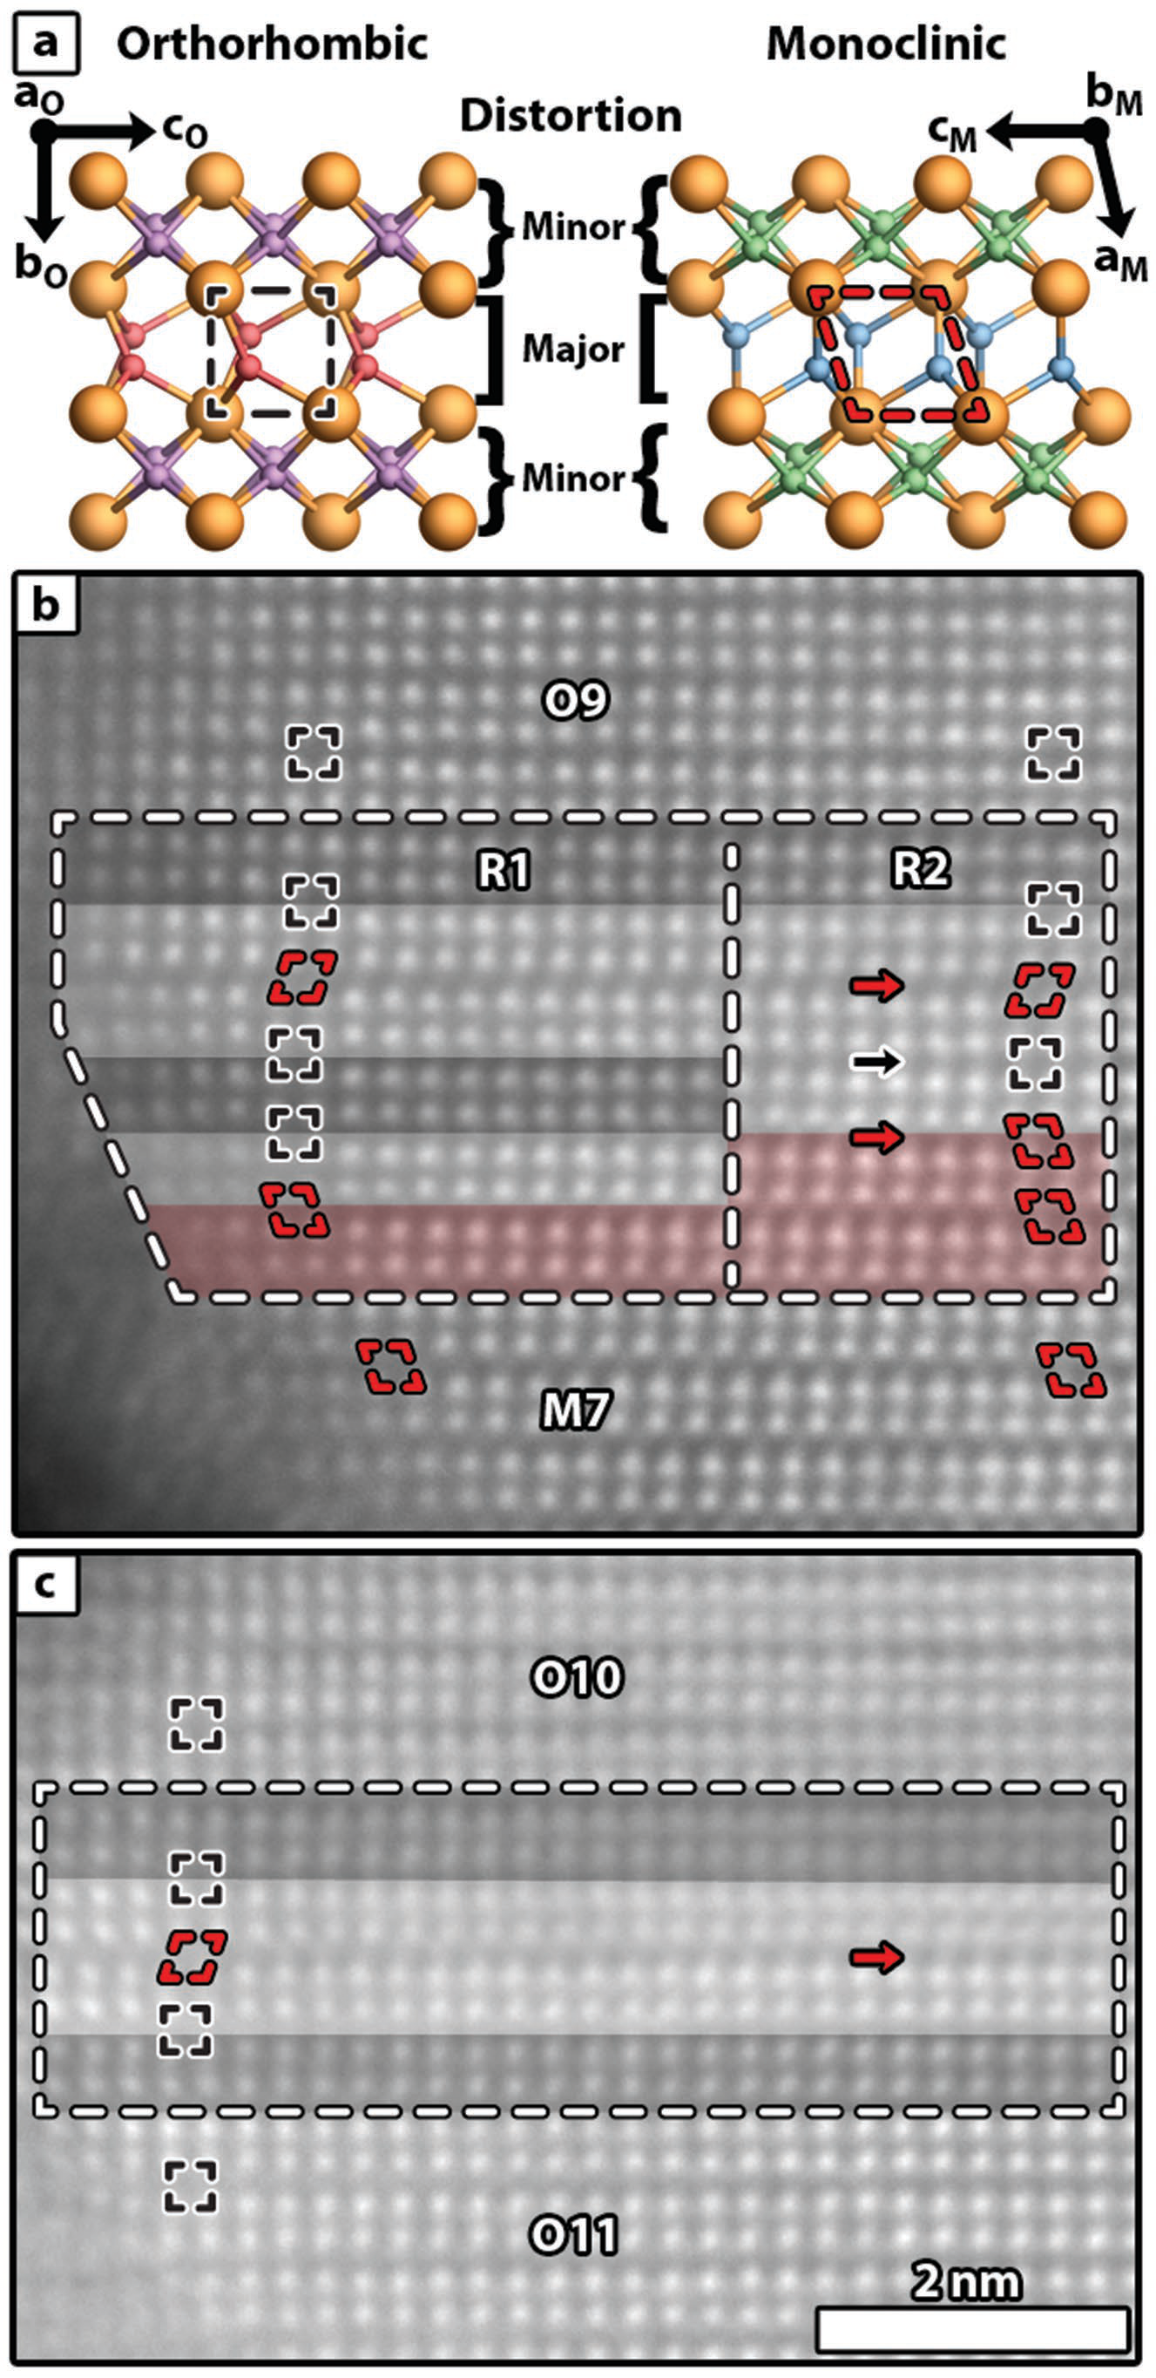



**3. Conclusions**

This work demonstrates the rich structural chemistry acces-  
sible to ferroelectric HfO2, which enables formation of a   
complex mixture of domains, planar defects, and interphase   
boundaries. The complex structure near interphase bounda-  
ries hints at a possible continuum between orthorhombic and   
monoclinic phases in the vicinity of the boundary walls. Fur-  
ther, the distortions present near these boundaries suggest the   
potential for mobility. These insights yield new perspectives   
for the modeling of switching and domain wall motion, and   
provide a basis for comparison to domain wall and interphase   
boundaries in conventional perovskite ferroelectrics. Overall,   
this work lays the groundwork for calculations aiming to   
explore interphase boundary energetics, where further knowl-  
edge is needed to improve stability, mobility, and their impact   
of field-cycling.

**4. Experimental Section**

*Sample Information*: 27 nm Gd:HfO2 capacitors with 10 nm TiN   
electrodes were grown using atomic layer deposition as described   
previously.[48] Lamella were prepared for scanning transmission electron   
microscopy (STEM) by focused ion beam from both cycled and pristine   
devices using an FEI Quanta. The lamella were extracted from either   
pristine (0 cycles), woken-up (1.0E+03 cycles), or samples after the   
onset of fatigue (2.15E+05 cycles) as indicated. Cycling was performed   
at 1 kHz with an 8.5 V triangular voltage sweep.[16]   
 *Scanning Transmission Electron Microscopy*: HAADF STEM was   
performed on an FEI Titan G2 60-300 kV equipped with a probe-  
corrector and an X-FEG source. The microscope was operated at 200 kV   
with a detector inner semiangle of ≈77 mrad, probe currents of around   
80 pA measured with the current monitor on the screen, and probe   
semiconvergence angle ≈19.6 mrad. RevSTEM images[49] were acquired   
using 40 1024 × 1024 pixel frames with a 2 µs pixel−1 dwell time and a   
90° rotation between each successive frame. Where necessary, scan coil   
distortion was removed by previously described methods.[50] The atom   
column positions were determined by fitting 2D Gaussian distributions   
via MATLAB scripting.[51] PACBED patterns were simulated using the   
MBFIT (“Many-Beam dynamical-simulations and least-squares FITting”)   
package by K. Tsuda at Tohoku University.[52] Simulation parameters   
matched those from experiment. Structural parameters were taken from   
refs. [11,41,53,54]. The simulation output was rescaled using bicubic   
interpolation to match experiment.

**Supporting Information**

**Figure 5.** a) Schematics of the O- and M-phases with the major and minor distortion half-units indicated. b) A complex interphase boundary in the woken-up sample with color-coded symmetry overlays (black: orthorhombic, red: monoclinic, and white: both), and important major distortion units indicated. Arrows highlight key structural figures described in the main text, and apparent symmetry of the distortion units is mapped. c) A similar boundary dividing two pure O-phase regions in the fatigued sample.

to certain regions of the sample, locking in a higher symmetry phase.[37] As such, the geometric constraints due to electrode(s), neighboring grain(s), and/or other boundaries may immobilize some of the interphase boundaries with little to no room to move around their eccentric positions.

Supporting Information is available from the Wiley Online Library or from the author.

**Acknowledgements**

Christoph Adelmann from Imec, Belgium is gratefully acknowledged for depositing the TiN-Gd:HfO2-TiN stacks. The authors thank Jacob L. Jones for helpful feedback and discussions. E.D.G. and J.M.L. gratefully acknowledge support from the National Science Foundation (DMR-1350273). E.D.G. acknowledges support for this work through a National Science Foundation Graduate Research Fellowship (DGE-1252376). T.S. gratefully acknowledges the German Research Foundation (Deutsche Forschungsgemeinschaft) for funding part of this research in the frame of the “Inferox” project (MI 1247/11-2). This work was performed in part

|  |  |  |
| --- | --- | --- |
| *Adv. Mater. Interfaces* **2018**, 1701258 | **1701258 (7 of 9)** | © 2018 WILEY-VCH Verlag GmbH & Co. KGaA, Weinheim |



at the Analytical Instrumentation Facility (AIF) at North Carolina State University, which is supported by the State of North Carolina and the National Science Foundation (ECCS-1542015). The AIF is a member of the North Carolina Research Triangle Nanotechnology Network (RTNN), a site in the National Nanotechnology Coordinated Infrastructure (NNCI).

**Conflict of Interest**

The authors declare no conflict of interest

[17] M. H. Park, H. J. Kim, Y. J. Kim, Y. H. Lee, T. Moon, K. D. Kim, S. D. Hyun, F. Fengler, U. Schroeder, C. S. Hwang, *ACS Appl. Mater. Interfaces***2016**, *8*, 15466.

[18] R. Materlik, C. Künneth, A. Kersch, *J. Appl. Phys.***2015**, *117*, 134109. [19] R. Batra, T. D. Huan, J. L. Jones, G. Rossetti, R. Ramprasad, *The*  *Journal of Physical Chemistry C***2017**, *121*, 4139.

[20] R. Batra, H. D. Tran, R. Ramprasad, *Appl. Phys. Lett.***2016**, *108*, 172902.

[21] S. E. Reyes-Lillo, K. F. Garrity, K. M. Rabe, *Phys. Rev. B***2014**, *90*, 140103.

[22] S. V. Barabash, D. Pramanik, Y. Zhai, B. Magyari-Kope, Y. Nishi, *ECS Trans.***2017**, *75*, 107.

[23] T. D. Huan, V. Sharma, G. A. Rossetti, R. Ramprasad, *Phys. Rev. B*

|  |  |
| --- | --- |
| **Keywords** | **2014**, *90*, 064111.  [24] S. Clima, D. J. Wouters, C. Adelmann, T. Schenk, U. Schroeder, |

domain walls, HAADF STEM, ferroelectric HfO2, interphase boundaries

Received: September 29, 2017   
Revised: November 13, 2017   
Published online:

[1] T. S. Böscke, J. Müller, D. Bräuhaus, U. Schröder, U. Böttger, *Appl.*  *Phys. Lett.***2011**, *99*, 102903.

[2] J. Müller, T. S. Böscke, U. Schröder, S. Mueller, D. Bräuhaus, U. Böttger, L. Frey, T. Mikolajick, *Nano Lett.***2012**, *12*, 4318.

[3] M. Pešic´, M. Hoffmann, C. Richter, T. Mikolajick, U. Schroeder, *Adv. Funct. Mater.***2016**, *26*, 7486.

[4] H. Mulaosmanovic, S. Slesazeck, J. Ocker, M. Pesic, S. Muller,

M. Jurczak, G. Pourtois, *Appl. Phys. Lett.***2014**, *104*, 092906.

[25] D. Martin, J. Müller, T. Schenk, T. M. Arruda, A. Kumar, E. Strelcov, E. Yurchuk, S. Müller, D. Pohl, U. Schröder, S. V. Kalinin, T. Mikolajick, *Adv. Mater.***2014**, *26*, 8198.

[26] M. H. Park, H. J. Kim, Y. J. Kim, Y. H. Lee, T. Moon, K. D. Kim, S. D. Hyun, C. S. Hwang, *Appl. Phys. Lett.***2015**, *107*, 192907.

[27] H. J. Kim, M. H. Park, Y. J. Kim, Y. H. Lee, T. Moon, K. D. Kim, S. D. Hyun, C. S. Hwang, *Nanoscale***2016**, *8*, 1383.

[28] H. Mulaosmanovic, J. Ocker, S. Müller, U. Schroeder, J. Müller, P. Polakowski, S. Flachowsky, R. van Bentum, T. Mikolajick, S. Slesazeck, *ACS Appl. Mater. Interfaces***2017**, *9*, 3792.

[29] T. Kiguchi, S. Nakamura, A. Akama, T. Shiraishi, T. J. Konno, *J. Ceram. Soc. Jpn.***2016**, *124*, 689.

[30] A. M. Glazer, P. A. Thomas, K. Z. Baba-Kishi, G. K. H. Pang, C. W. Tai, *Phys. Rev. B***2004**, *70*, 184123.

[31] G. A. Rossetti, A. G. Khachaturyan, G. Akcay, Y. Ni, *J. Appl. Phys.*

S. Flachowsky, J. Müller, P. Polakowski, J. Paul, S. Jansen, **2008**, *103*, 114113.

S. Kolodinski, C. Richter, S. Piontek, T. Schenk, A. Kersch, C. Kunneth, R. van Bentum, U. Schroder, T. Mikolajick, in *2015 IEEE IEDM*, IEEE, Washington, DC **2017**, pp. 26.8.1–26.8.3.

[32] D. Damjanovic, in *The Science of Hysteresis* (Eds: G. Bertotti, I. D. Mayergoyz), Academic Press, Oxford **2006**, pp. 337–465.

[33] C. Ma, H. Guo, S. P. Beckman, X. Tan, *Phys. Rev. Lett.***2012**, *109*,

[5] M. Hoffmann, M. Pešic´, K. Chatterjee, A. I. Khan, S. Salahuddin, 107602.

S. Slesazeck, U. Schroeder, T. Mikolajick, *Adv. Funct. Mater.***2016**, [34] J. L. Jones, E. Aksel, G. Tutuncu, T.-M. Usher, J. Chen, X. Xing,

*26*, 8643. A. J. Studer, *Phys. Rev. B***2012**, *86*, 024104.

[6] M. Dragoman, M. Aldrigo, M. Modreanu, D. Dragoman, *Appl. Phys.*  [35] J. M. LeBeau, S. D. Findlay, L. J. Allen, S. Stemmer, *Ultramicroscopy*

*Lett.***2017**, *110*, 103104. **2010**, *110*, 118.

[7] M. Hoffmann, U. Schroeder, C. Künneth, A. Kersch, S. Starschich, U. Böttger, T. Mikolajick, *Nano Energy***2015**, *18*, 154.

[8] M. H. Park, H. J. Kim, Y. J. Kim, T. Moon, K. D. Kim, Y. H. Lee, S. D. Hyun, C. S. Hwang, *Adv. Mater.***2016**, *28*, 7956.

[9] S. W. Smith, A. R. Kitahara, M. A. Rodriguez, M. D. Henry,

[36] J. E. Bailey, *Proc. R. Soc. London, Ser. A***1964**, *279*, 395.

[37] I. MacLaren, T. Ras, M. MacKenzie, A. J. Craven, D. W. McComb, S. D. Gendt, *J. Electrochem. Soc.***2009**, *156*, G103.

[38] J. Tang, F. Zhang, P. Zoogman, J. Fabbri, S.-W. Chan, Y. Zhu, L. E. Brus, M. L. Steigerwald, *Adv. Funct. Mater.***2005**, *15*,

M. T. Brumbach, J. F. Ihlefeld, *Appl. Phys. Lett.***2017**, *110*, 1595.

072901. [39] B. M. Hudak, S. W. Depner, G. R. Waetzig, A. Talapatra, R. Arroyave,

[10] D. M. Adams, S. Leonard, D. R. Russell, R. J. Cernik, *J. Phys. Chem.*  S. Banerjee, B. S. Guiton, *Nat. Commun.***2017**, *8*, 15316.

*Solids***1991**, *52*, 1181. [40] C. Künneth, R. Materlik, A. Kersch, *J. Appl. Phys.***2017**, *121*,

[11] X. Sang, E. D. Grimley, T. Schenk, U. Schroeder, J. M. LeBeau, 205304.

*Appl. Phys. Lett.***2015**, *106*, 162905. [41] E. H. Kisi, C. J. Howard, R. J. Hill, *J. Am. Ceram. Soc.***1989**, *72*,

[12] C. Richter, T. Schenk, M. H. Park, F. A. Tscharntke, E. D. Grimley, 1757.

J. M. LeBeau, C. Zhou, C. M. Fancher, J. L. Jones, T. Mikolajick, [42] S.-H. Guan, X.-J. Zhang, Z.-P. Liu, *J. Am. Chem. Soc.***2015**, *137*,

U. Schroeder, *Adv. Electron. Mater.***2017**, *3*, 1700131. 8010.

[13] M. H. Park, T. Schenk, C. M. Fancher, E. D. Grimley, C. Zhou, C. Richter, J. M. LeBeau, J. L. Jones, T. Mikolajick, U. Schroeder, *J. Mater. Chem. C***2017**, *5*, 4677.

[14] T. Shimizu, K. Katayama, T. Kiguchi, A. Akama, T. J. Konno,

[43] Y. H. Chiao, I.-W. Chen, *Acta Metall. Mater.***1990**, *38*, 1163.

[44] B. C. Muddle, R. H. J. Hannink, in *Advances in Ceramics, Vol. 24, Science and Technology of Zirconia III* (Eds: S. Sömya, N. Yamamoto, H. Yanagida), American Ceramic Society, Westerville, OH **1988**,

H. Funakubo, *Appl. Phys. Lett.***2015**, *107*, 032910. pp. 89–102.

[15] M. Pešic´, F. P. G. Fengler, L. Larcher, A. Padovani, T. Schenk, [45] G. Trolliard, D. Mercurio, J. M. Perez-Mato, *Z. Kristallogr.***2011**, *226*,

E. D. Grimley, X. Sang, J. M. LeBeau, S. Slesazeck, U. Schroeder, 264.

T. Mikolajick, *Adv. Funct. Mater.***2016**, *26*, 4601.

[16] E. D. Grimley, T. Schenk, X. Sang, M. Pešic´, U. Schroeder, T. Mikolajick, J. M. LeBeau, *Adv. Electron. Mater.***2016**, *2*,

[46] S. Liu, W. Hu, Y. Zhang, J. Xiang, F. Wen, B. Xu, J. He, D. Yu, Y. Tian, Z. Liu, *J. Appl. Crystallogr.***2014**, *47*, 684.

[47] T. Schenk, M. Hoffmann, J. Ocker, M. Pešic´, T. Mikolajick,

1600173. U. Schroeder, *ACS Appl. Mater. Interfaces***2015**, *7*, 20224.

*Adv. Mater. Interfaces* **2018**, 1701258 **1701258 (8 of 9)** © 2018 WILEY-VCH Verlag GmbH & Co. KGaA, Weinheim



[48] M. Hoffmann, U. Schroeder, T. Schenk, T. Shimizu, H. Funakubo, [51] X. Sang, A. A. Oni, J. M. LeBeau, *Microsc. Microanal.***2014**, *20*, 1764.

O. Sakata, D. Pohl, M. Drescher, C. Adelmann, R. Materlik, [52] K. Tsuda, M. Tanaka, *Acta Crystallogr., Sect. A: Found. Crystallogr.* A. Kersch, T. Mikolajick, *J. Appl. Phys.***2015**, *118*, 072006. **1999**, *55*, 939.

[49] X. Sang, J. M. LeBeau, *Ultramicroscopy***2014**, *138*, 28. [53] O. Ohtaka, T. Yamanaka, S. Kume, *J. Ceram. Soc. Jpn.***1991**, *99*, [50] J. H. Dycus, J. S. Harris, X. Sang, C. M. Fancher, S. D. Findlay, 826.

A. A. Oni, E. C. Tsung-ta, C. C. Koch, J. L. Jones, L. J. Allen, [54] O. Ohtaka, T. Yamanaka, S. Kume, N. Hara, H. Asano, F. Izumi, D.L. Irving, J.M. LeBeau, *Microsc. Microanal.***2015**, *21*, 946. *J. Am. Ceram. Soc.***1995**, *78*, 233.

*Adv. Mater. Interfaces* **2018**, 1701258 **1701258 (9 of 9)** © 2018 WILEY-VCH Verlag GmbH & Co. KGaA, Weinheim